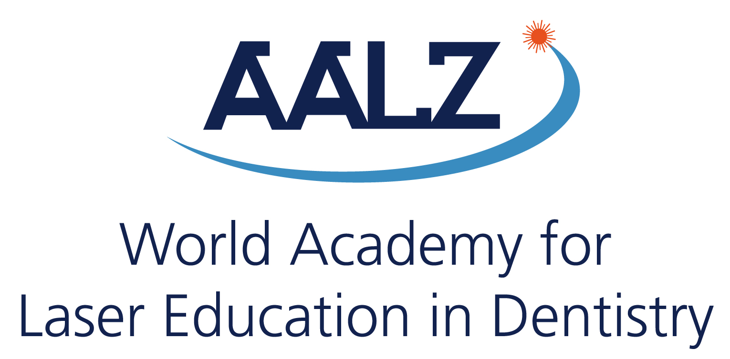
WALED
5th. Congress in Thessaloniki, Greece
21 September 2017 – Makedonia Palace Hotel
A joint congress with the WFLD European Division, which will be held from 22-23 September 2017 (of course you can also additionally present at WFLD!)
Call for Papers
Deadline for submission: 01.07.2017

Presentation Title:

Author(s):

Institute(s) / Clinic(s):

Address :
Tel: Fax: Email:

Abstract:
(max. 250 words in Times New Roman, font 11 points)
Session: Kind of submission:
(1) Scientific session (1) Oral presentation
(2) Case presentation (2) Poster presentation
Classification: | Title:
(1) Basic research  (2) Cariology  (3) Caries removal  (4) Clinical observation  (5) Clinical study  (6) Diagnosis  (7) Endodontics  (8) Periodontics  (9) Prevention  (10) Laser Safety  (11) Surgery, Soft tissue management  (12) Others, please indicate: ____________ | The title must be short and give information about the main content  Authors:  Please write the surnames in capital letters. Mark the name of the presenter with an asterisk (*)  Content:  Goal, material & methods, results and discussion  Technics:  Keynote and Power Point only, video-projection  Others:  Pls send us your short CV and a passport photo for presentation!
Address: Leon Vanweersch, AALZ GmbH - Aachen Dental Laser Center, Pauwelsstraße 17, 52074 Aachen, Germany
Tel: +49 241 47571313, Email: vanweersch@aalz.de

