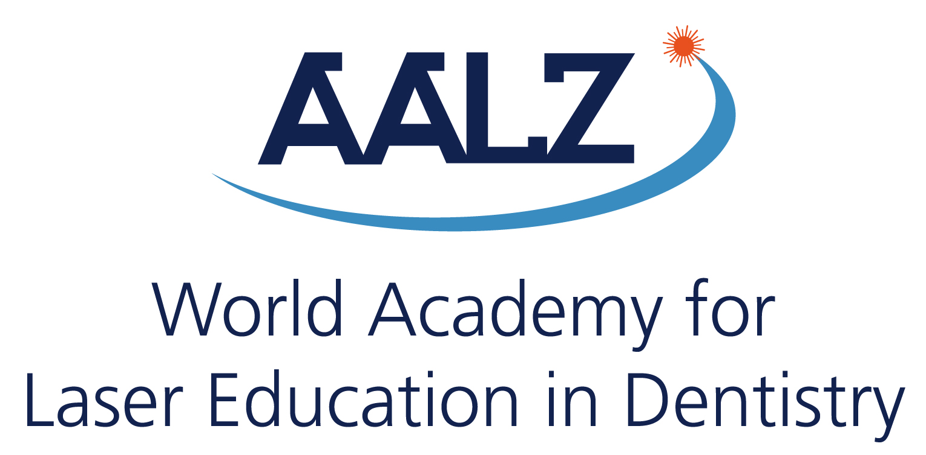
WALED
8th. Congress in Cairo - Egypt
1 October 2020 – Cairo Marriott Hotel
A joint congress with the ISLD, which will be held from 1-3 October 2020 (of course you can also additionally present at ISLD by filling in the ISLD call for abstract!)
Call for Papers
Deadline for submission: 01.06.2020

Presentation Title:

Author(s):

Institute(s) / Clinic(s):

Address :
Tel: Fax: Email:

Abstract:
(max. 250 words in Times New Roman, font 11 points)
Session: Kind of submission:
(1) Scientific session (1) Oral presentation
(2) Case presentation (2) Poster presentation
Classification: | Title:
(1) Basic research  (2) Cariology  (3) Caries removal  (4) Clinical observation  (5) Clinical study  (6) Diagnosis  (7) Endodontics  (8) Periodontics  (9) Prevention  (10) Laser Safety  (11) Surgery, Soft tissue management  (12) Others, please indicate: ____________ | The title must be short and give information about the main content  Authors:  Please write the surnames in capital letters. Mark the name of the presenter with an asterisk (*)  Content:  Goal, material & methods, results and discussion  Technics:  Keynote and Power Point only, video-projection  Others:  Pls send us your short CV and a passport photo for presentation!
Address: Leon Vanweersch, AALZ GmbH - Aachen Dental Laser Center, Pauwelsstraße 19, 52074 Aachen, Germany
Tel: +49 241 47571313, Email: vanweersch@aalz.de

